**Embedded System Lab (CS-16203)**

**Assignment-3**

**To be done using EdSim51 simulator:**

1. **Implement an assembly language program to check whether the given number is prime or not.**

**ORG ØØH**

**LABELS: MOV A,R2**

**MOV B, #02**

**DIV AB**

**MOV RØ, A**

**CJNE RØ, #Ø1H, LABEL2**

**MOV R5, #Ø1h**

**SJMP LABEL4**

**LABEL1: DEC RØ**

**CJNE RØ, #01, LABEL2**

**MOV R5, #01H**

**SJMP LABEL4**

**LABEL2: MOV A,R2**

**MOV BRØ**

**DIV AB**

**MOV R3,B**

**CJNE R3, #ØH, LABEL1**

**MOV R5, #H**

**LABEL4:**

**END**

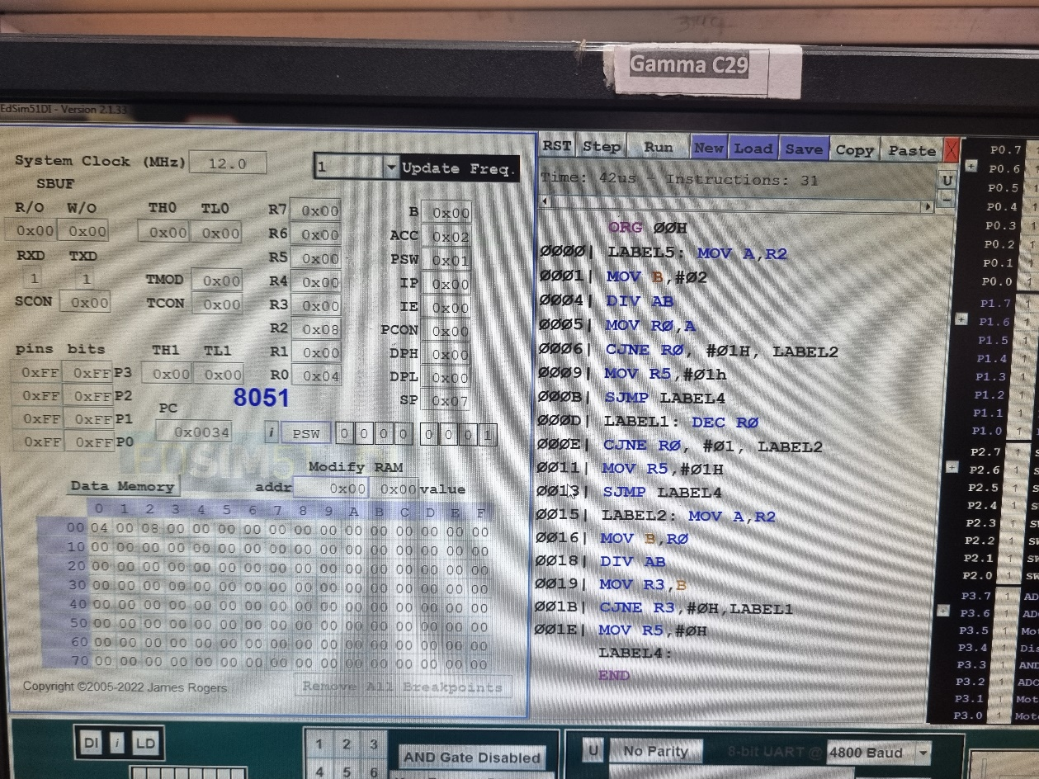

1. **Write an assembly language program for “Addition of Array of numbers” in Edsim51.**

**ORG ØØH**

**MOV R3, #ØH CARRY**

**MOV RØ, #ØAH**

**SIZE OF ARRAY**

**MOV R1, #30H STARTING Address**

**MOV A, #ØØH CLEAR A**

**LOOP: ADDC A, @R1**

**JNC NEXT**

**INC R3**

**NEXT: INC R1**

**DJNZ RØ, LOOP**

**MOV @R1,A**

**INC R1**

**MOV A,R3**

**MOV @R1, A**

**END**

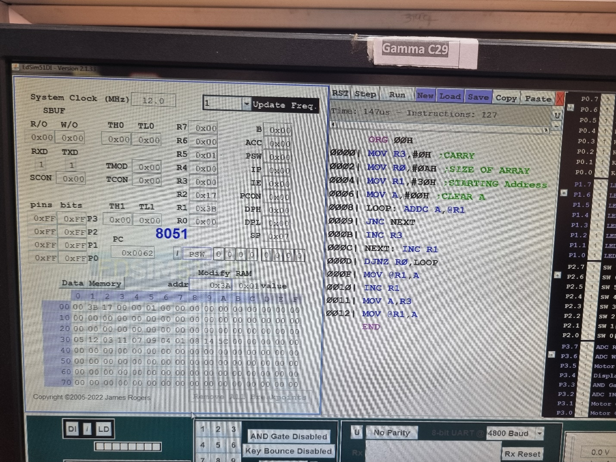

**3. Move a block of data from one memory location to other where memory is addressed through indirect mode in both overlapping and non overlapping case.**

**Non overlapping:**

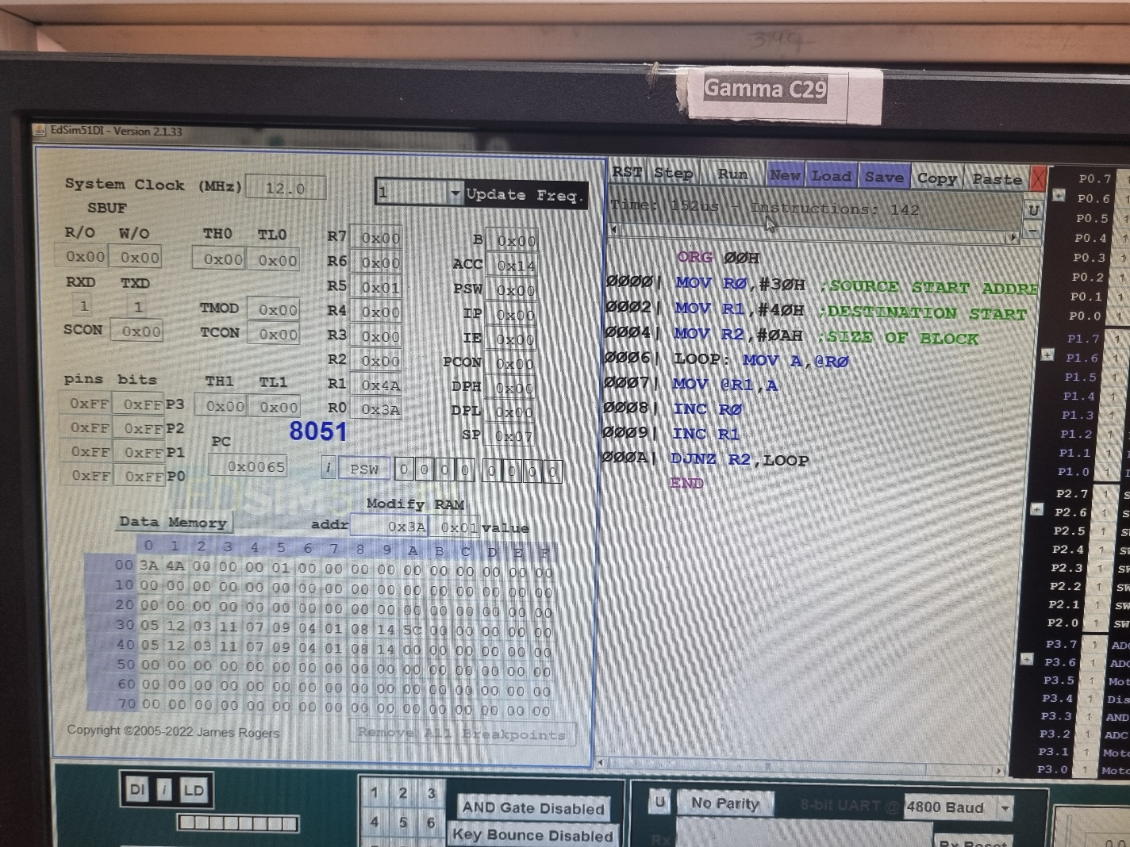

**Overlapping:**

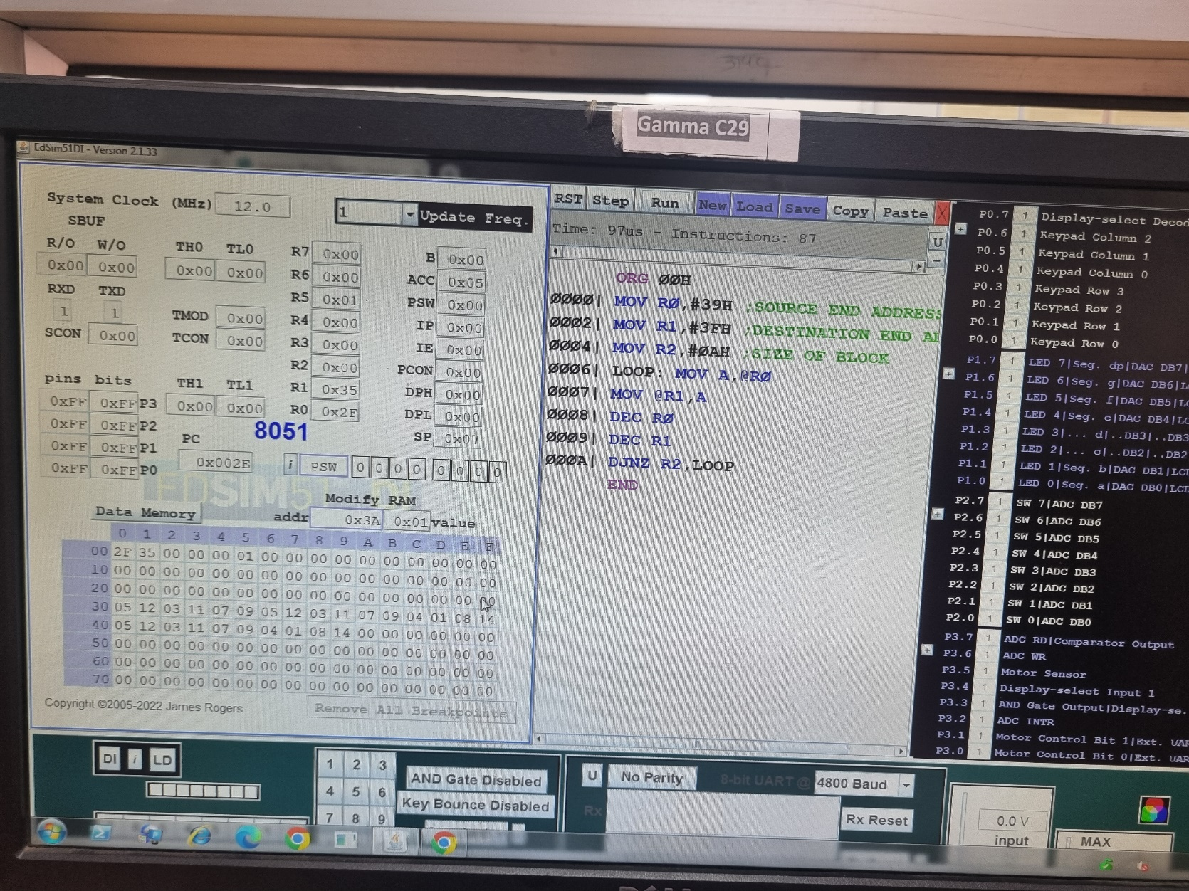

**4. Implement an assembly language program to “exchange data blocks of 10 bytes.**

**ORG ØØH**

**MOV RØ, #30H**

**SOURCE START ADDRE**

**MOV R1, #4ØH**

**DESTINATION START**

**MOV R2, #ØAH**

**SIZE OF BLOCK**

**LOOP: MOV A,RØ**

**MOV B, @R1**

**MOV @R1, A**

**MOV RO, B**

**INC RØ**

**INC R1**

**DJNZ R2, LOOP**

**END**

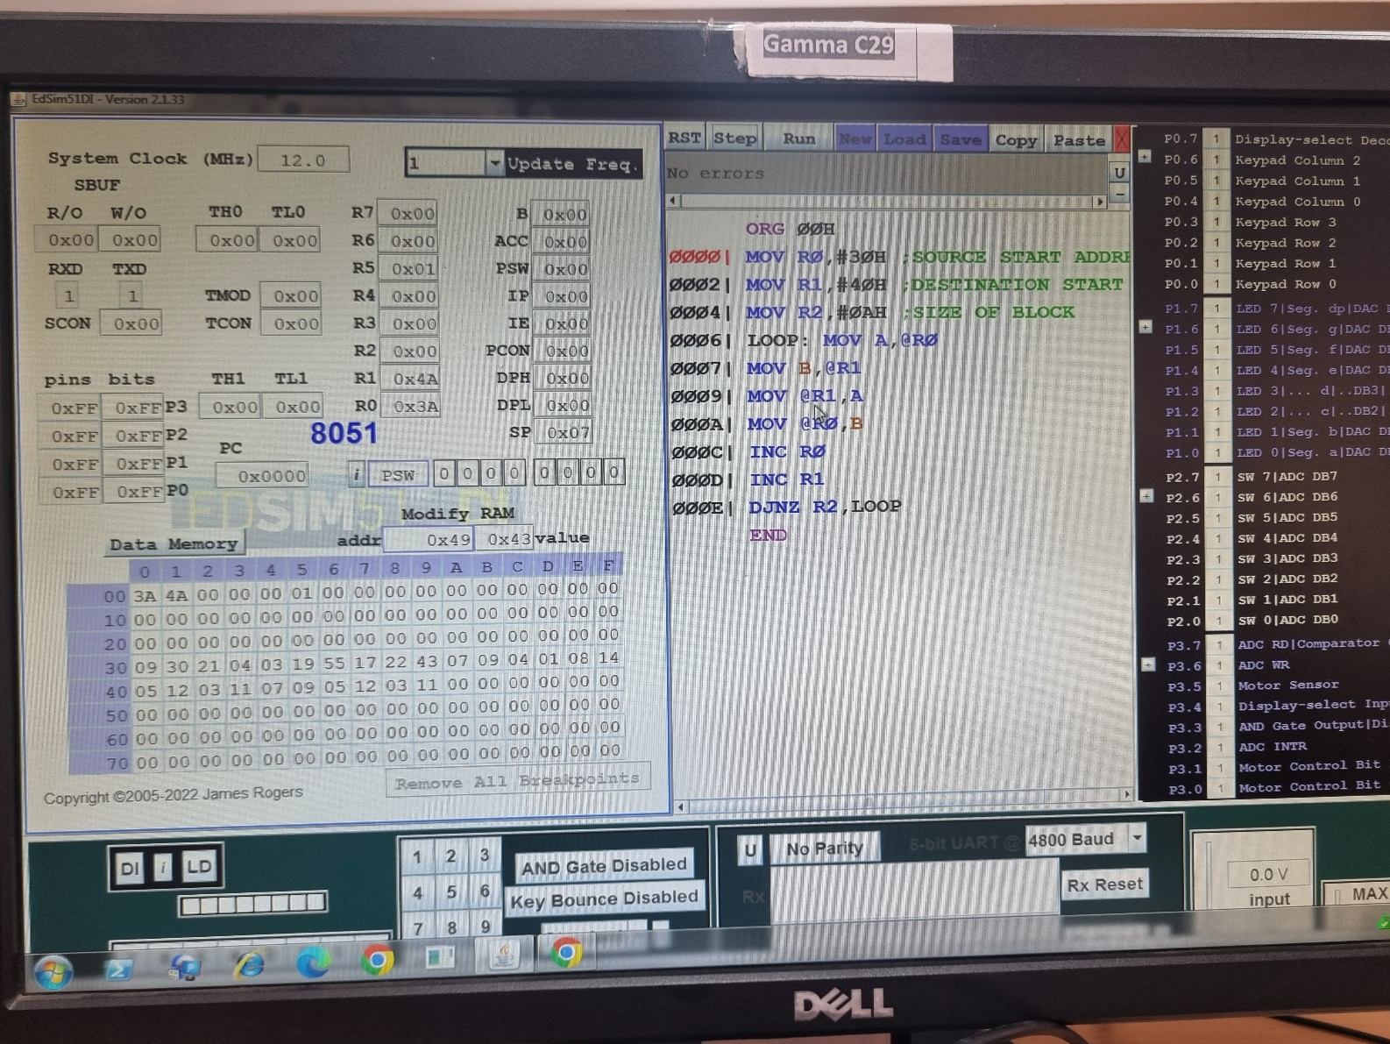

**Input:**

